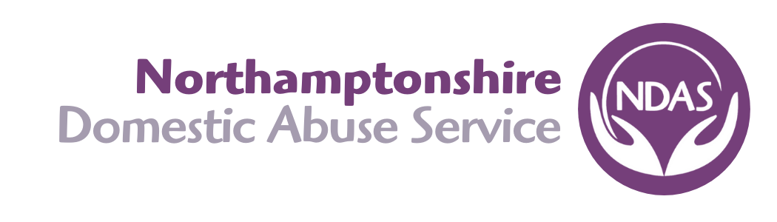

**SAFEGUARDING POLICY**

**CHILDREN**

Northamptonshire Domestic Abuse Service takes seriously its obligations in safeguarding and promoting the welfare of children. If it comes to light by any member of NDAS staff that a child has been or is being abused in any way, that member of staff will inform the person disclosing the information that they will have to report the disclosure to a senior member of staff in line with safeguarding procedures.

NDAS operate a clear line of accountability for the responsibility of the organisation’s safeguarding arrangements and promote a culture of listening to children and taking account of their wishes and feelings. NDAS’s Child Safeguarding Procedures set out clearly the processes for sharing information with other professionals should a disclosure be reported and are undertaken in line with the procedures set by the Local Safeguarding Children Board (LSCB).

NDAS have in place recruitment practices for individuals whom the organisation will permit to work with children and strict policies are in place in obtaining checks with the Disclosure Barring Service.

**PROCEDURE**

NDAS follows the guidelines of the Local Safeguarding Children’s Board: <http://www.northamptonshirescb.org.uk/>

All staff, including volunteers will abide by these procedures at all times.

The definition of abuse and neglect can be found within Working Together 2015 which can be found here:

<https://www.gov.uk/government/publications/working-together-to-safeguard-children--2>. A web browser and mobile devise compatible version is also available here: <http://www.workingtogetheronline.co.uk/>

**How NDAS will support women who are finding it difficult to cope with their child/children both in refuge and within the community**

NDAS recognises that families may bring their children up differently, and it is important to be sensitive and tolerant of customs and views which may be held by service users, while at the same time making clear what is acceptable behaviour and what is not.

NDAS acknowledges how difficult living in a refuge can be and the effects it can have on a child’s behaviour. Staff members will work closely with women in refuge through their Individual Support Plan to assist them in developing appropriate parenting skills and responses. This will include giving women practical and emotional support, as well as providing information about support from other agencies (for both them and their child/children).

**NDAS *will offer training and information sessions about positive parenting, including alternative ways to manage children’s behaviour in a non-threatening way. Support Workers will also offer additional support to children and young people by referring them to partner agencies or other team members who can focus on helping them cope better.***

## What you should do if you suspect a child is being abused

1. Everyone working for NDAS has a responsibility to report their concerns to ensure all children and young people are safe. If you are concerned that a child is suffering harm or is likely to suffer harm from another person you have a responsibility to protect the child by ***reporting your concern to your DSO immediately***
2. There are many forms of abuse and some are less clear than others, although this does not mean that they are less harmful. What you see and what you know about a child is important and should be acted on.
3. *If another service user has reported the abuse, staff must maintain confidentiality by not discussing the case further with the person reporting it.*
4. *If support is required the Operations Manager will designate a member of staff to provide this support and will work with the staff member to resolve the situation in the refuge, unless sexual or other severe abuse is involved. In all cases of abuse, NDAS will, in their capacity to protect the child, report their concerns to MASH*
5. *In all cases the decision to make a referral to MASH must be discussed with your DSO or your line manager in the absence of the DSO.*
6. The mother/carer of the child/ren involved should be informed of the decision before the referral is made. Only in exceptional circumstances should the woman be informed after the referral has been made. An exceptional circumstance would mean that staff had good reason to believe the child/ren would be at greater risk if staff informed the mother/carer of their decision to refer before the appropriate agency contacted her.
7. If a child/ren discloses or child abuse is suspected and the child/ren are no longer at risk because they are living in the refuge away from the alleged abuser staff must still refer to outside agencies. This will enable the child/ren and the mother/carer to receive the necessary support and would also help protect a child that may at some point be taken back to the abusive environment.
8. If a child discloses abuse, staff must always refer to MASH*.* Upon disclosure the child/ren should always be believed and reassured that they are not in trouble for speaking out. The child should also be assured that although certain individuals must be told in order to help the child, the information will not become common knowledge.
9. In order to respect confidentiality, teenagers who disclose must be encouraged to tell their mother/carer, with the support of a worker. If the mother/carer is the abuser staff will make a referral on the young person’s behalf without informing the mother/carer if the young person so wishes.
10. If a woman leaves a refuge and a referral has been made (or decision to refer is made) to outside agencies staff will encourage her to inform Social Care & Health of her decision to move on. In any case as part of the case closure procedure the appropriate Support Worker will inform Social Care & Health of the client’s departure from refuge and, if known, the forwarding address.
11. If the child/ren are old enough to understand, they must be informed of other options available to them so that they do not have to return to an abusive situation.
12. If it is suspected or apparent that the mother/carer is the abuser, external advice and support must be sought immediately.
13. NDAS recognises that both the child and mother will require support during the process of a referral being made.
14. If it becomes apparent or is suspected that a child living in the refuge has abused another child also resident in the refuge, members of staff will talk to the mothers/carers of all the children involved before referring to outside agencies. It may also be appropriate in this situation to move one or both families involved to other accommodation.
15. If a worker orvolunteer abuses a child resident in the refuge then the relevant disciplinary procedures will be used and the Police and Social Services will be informed immediately.
16. ***If a child/ren is abused by another adult resident, the child in accordance with her/his age and maturity and the mother/carer of the child will be advised of the options available to them and possible courses of action that they may take. The support worker has a duty of care to report this to MASH or Police depending on the severity of abuse and threat of immediate danger to the child/ren***
17. If in refuge, the Support Worker in collaboration with senior management will decide whether the behaviour of the abuser warrants eviction or a move to other accommodation managed by NDAS.
18. ***When informing a mother/carer of a decision to refer to external agencies, the support worker after consulting with he DSO, should make them aware***
19. All action taken, including the contents of phone calls, letters, and conversations in relation to this policy **must** be carefully and accurately recorded.
20. If there is an immediate and serious threat to the child/ren, support worker should consider use of 999.
21. If the concerns are about a member of staff or a volunteer then the DSO and Chief Executive must be consulted immediately. They will ensure that the allegations against staff procedure will be followed which can be found here: <http://www.proceduresonline.com/northamptonshire/scb/p_alleg_against_staff.html>

**VULNERABLE ADULTS**

An adult is defined as ‘vulnerable’ where s/he is ‘aged 18 years or over (and) is or may be in need of community care services because they have health or other disabilities related to age or illness. They are people unable to take care of themselves or to protect themselves against significant harm or exploitation’.

NDAS will work with Northamptonshire County Council in connection with its inter-agency policy ‘Northamptonshire Safeguarding Vulnerable Adults from Abuse’ available on the Council’s website at [**http://www3.northamptonshire.gov.uk/councilservices/adult-social-care/safeguarding/Pages/safeguarding-adults-forms.aspx**](http://www3.northamptonshire.gov.uk/councilservices/adult-social-care/safeguarding/Pages/safeguarding-adults-forms.aspx)

Any potential referral in connection with suspected elder abuse will be considered by the Senior Management Team.

**PROCEDURE**

Where a referral is made of a person who may be regarded as a vulnerable adult, the DSO must be consulted in the first instance. Effective safeguarding is achieved when agencies share information to obtain an accurate picture of the risk and then work together to ensure that the safety of the adult at risk is prioritised, with cases involving vulnerable adults it may be relevant to access the multi-agency risk assessment conference (MARAC) process.

**FLOWCHART**

Child/vulnerable adult identified as ‘at risk’



Discuss concerns with DSO

Provide full details of reported incidents and forward report to DSO



If there are still concerns discuss with NDAS DSO who will contact the Multi Agency Safeguarding Hub (MASH) or Local Authority Designated Officer (LADO) if there is an allegation against staff or volunteer.

|  |  |
| --- | --- |
| **Reviewed:** | May 2023 |
| **Next Review:** | May 2024 |
| **Signed: Rachel Duncan, CEO** |  |